A NEW TECHNIQUE FOR SEISMOGRAMS CALCULATION IN A LAYERED HALF-SPACE, AS APPLIED TO SEISMIC MOMENT TENSOR INVERSIONS

V.M. Pavlov

Kamchatka Experimental and Methodical Seismological Department
Petropavlovsk-Kamchatsky, Russia

A new discrete wave-number technique for synthetic seismogram calculation is proposed for the case of a point source with an arbitrary moment tensor. In the frequency domain a solution is represented by series over discrete wave-numbers. To do this, an artificial remote cylindrical boundary is introduced, following Alekseev and Mikhailenko (1976). To obtain such a representation, the proper conditions on the boundary are formulated. The discrete wave-numbers are the roots of Bessel functions divided by the distance to the remote boundary. The unknown coefficients of the series are components of stress-motion vectors for SH- and P/SV-waves. These coefficients satisfy two independent systems of ordinary differential equations of 1st order in depth variable. A new method for solving these equations is proposed based on introducing of impedance functions. For a given depth an impedance is a matrix H such that a motion vector multiplied by H gives the corresponding stress vector. For the SH case the impedance is a scalar whereas for the P/SV case it is 2x2 matrix one. Explicit analytical formulas for impedances are given. Stress-motion vectors are expressed through the impedance by formulas that also have explicit analytical form. These formulas do not include exponential functions with real positive arguments. Therefore layers with arbitrary thickness are acceptable. To avoid singularities a small imaginary quantity is added to frequencies; arising distortions are then compensated in the time domain. The algorithm leads to the numerical procedure that is compact and computationally stable. The initial version of the technique was presented in (Pavlov, 2002). A computer program based on the technique was developed.

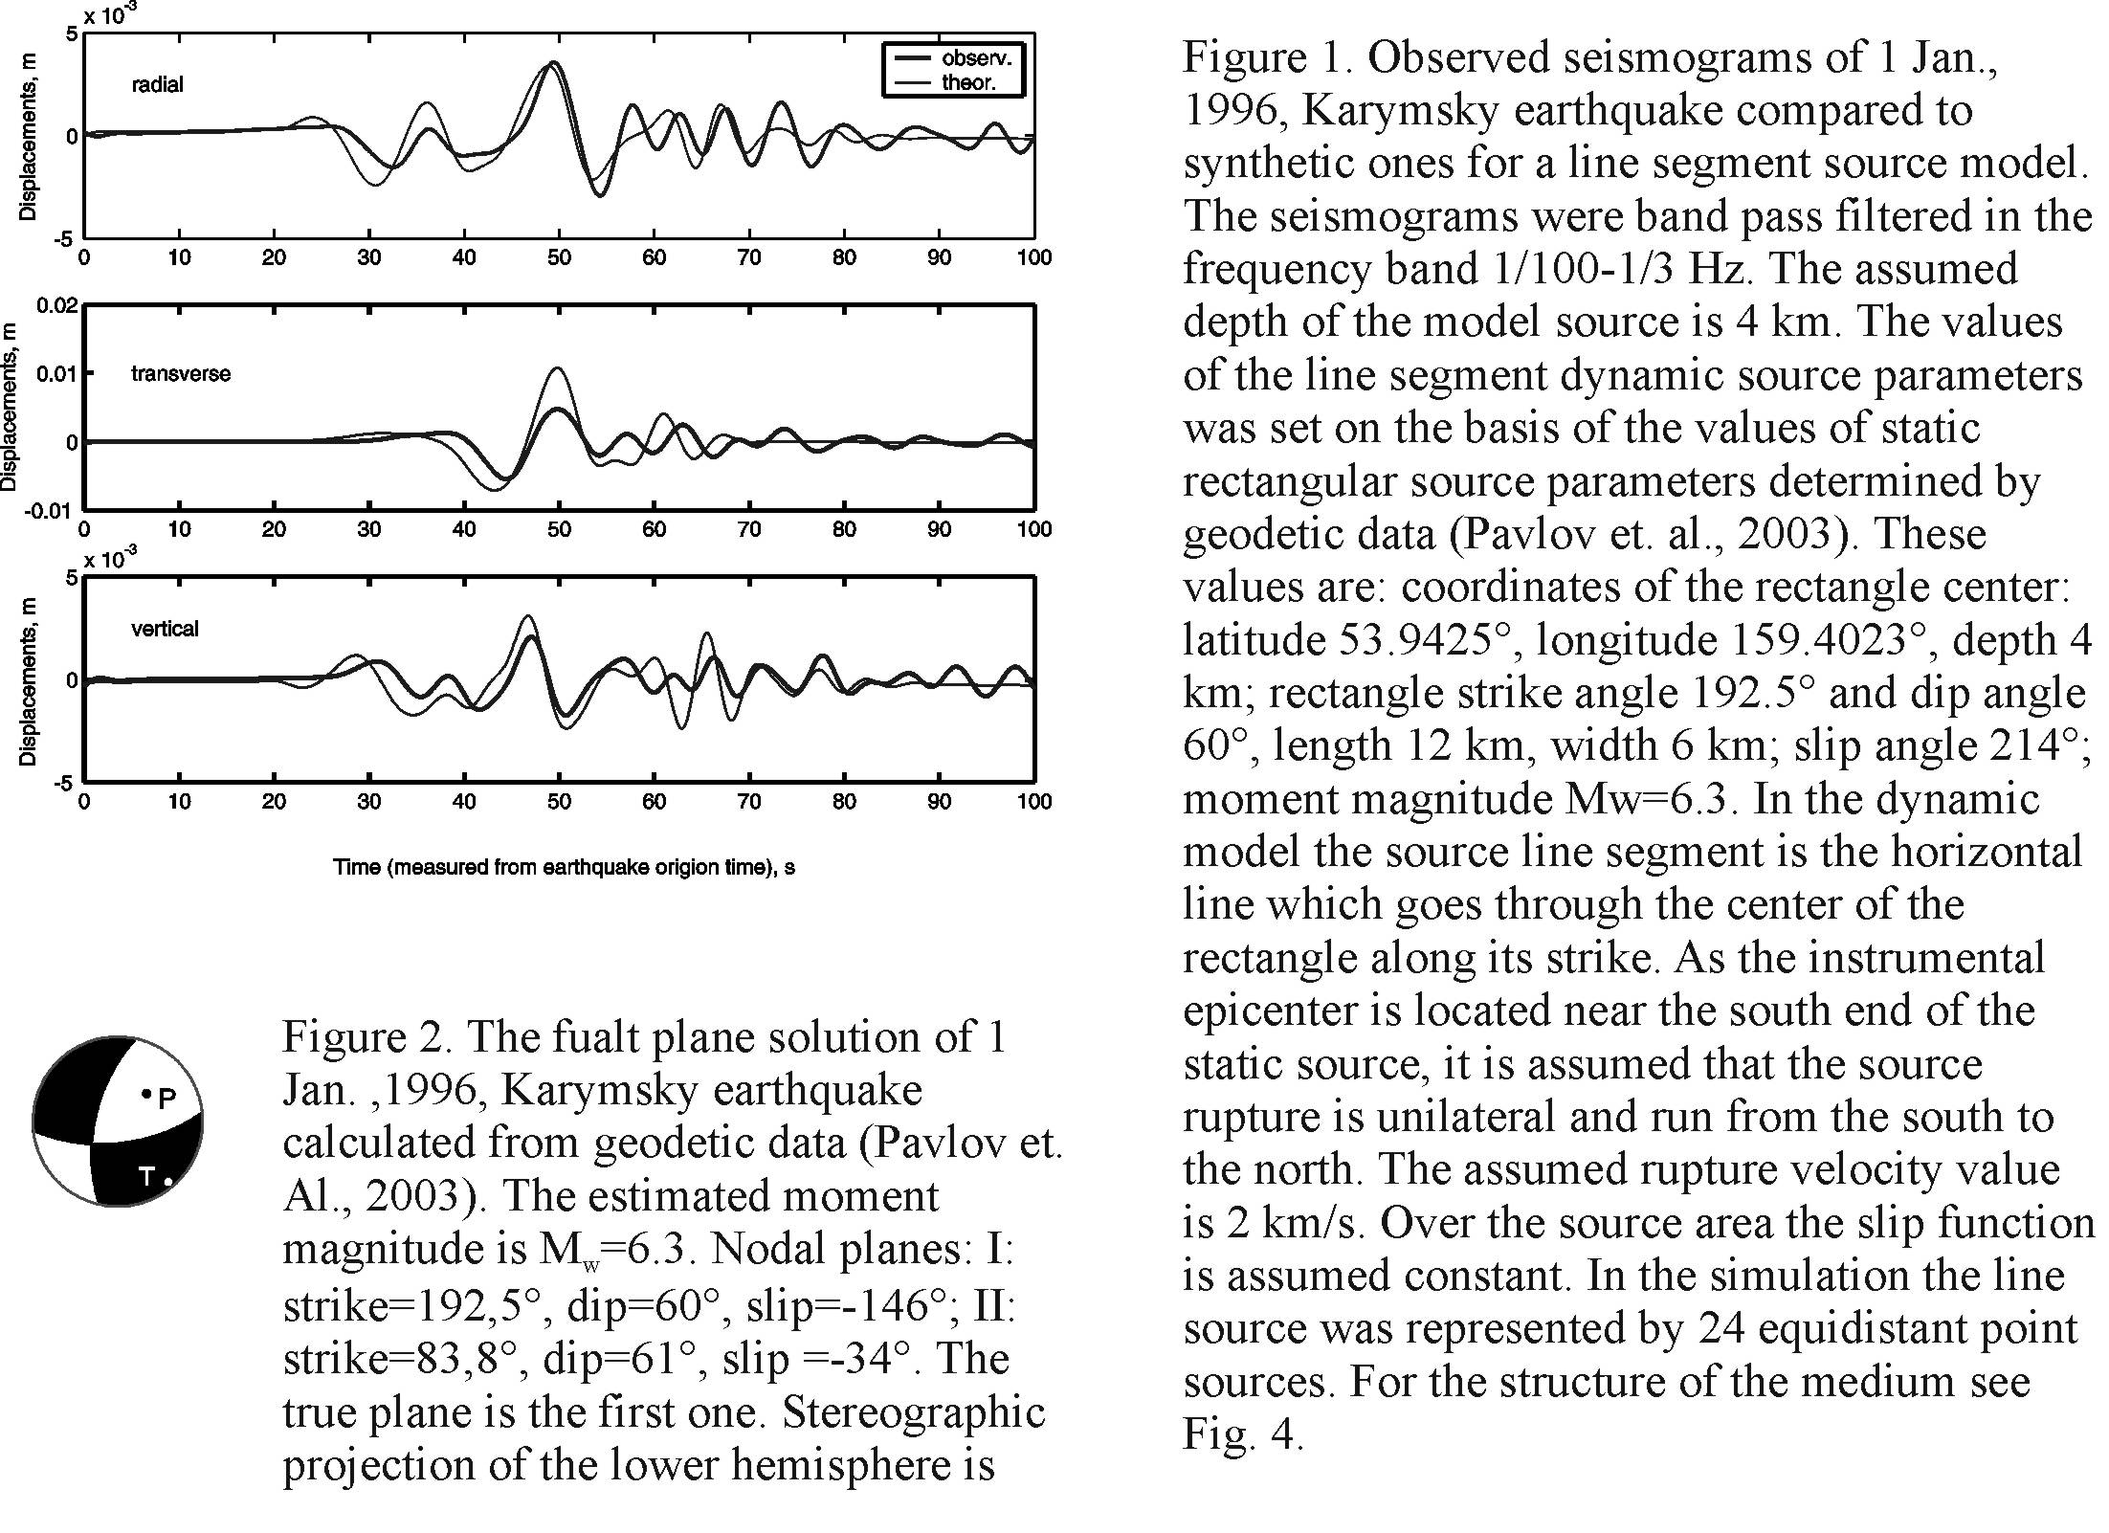
For the 1 Jan., 1996, Karymsky earthquake, Ms=7.0, seismograms filtered in the frequency band 1/100-1/3 Hz for an extended (linear) source was calculated (Fig.1). The mechanism (Fig.2) was used. It was determined earlier by geodetic data (Pavlov et. al., 2003). The observed seismograms are obtained from the records at PET IRIS, BB channel.

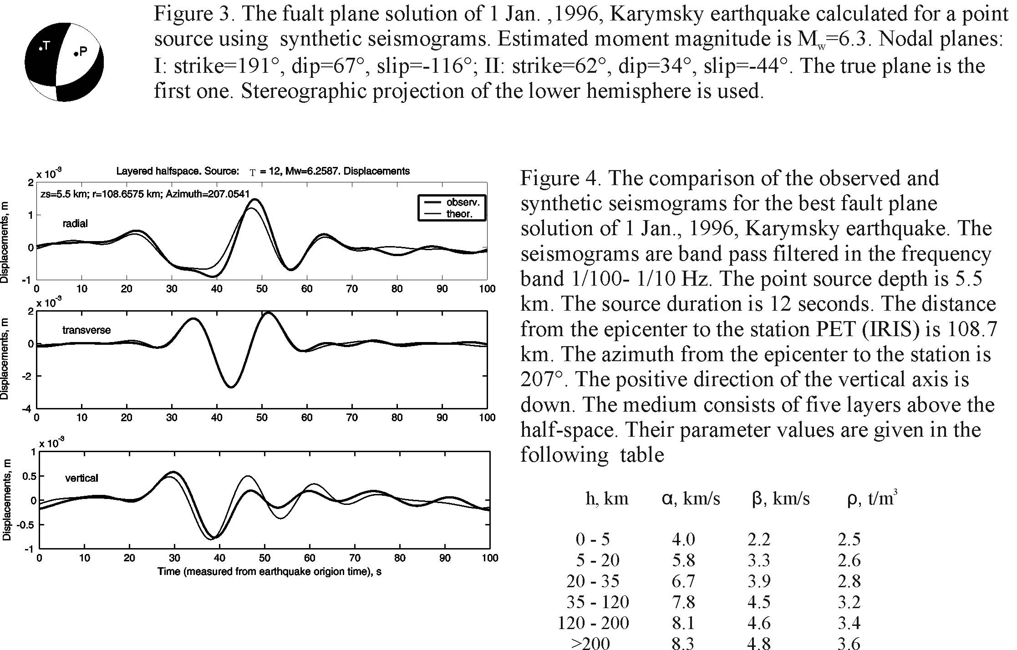

The program is applied for estimation of the seismic moment tensor M_{ij} of a point source using a three-component broadband seismogram. The procedure includes: 1) deconvolution of the observed seismogram; 2) calculation of the influence functions of the M_{ij} for a set of depths; 3) low pass filtration; 4) calculation of M_{ij} by linear inversion for each depth at the fixed duration T of the source function; 5) evaluation of T at a given depth (by criterion of the least misfit); 6) evaluation of the source depth (by criterion of the least misfit).
As an example a mechanism for the Jan1, 1996, Karymsky earthquake was determined (Fig.3). The broadband seismograms at PET IRIS, BB channel, were used. Figure 4 shows quality of the fitting.

References

- Alekseev A.S., Mikhilenko B.G., 1976. Solution of Lamb problem for a vertically inhomogeneous elastic half-space. Izv. Akad. Nauk USSR, Fizika Zemli, 12, 11-25 (in Russian).
- Pavlov V., 2002. A convenient technique for calculating synthetic seismograms in a layered half-space. Proceedings of the 4th International Conference «Problems of Geocosmos». St. Petersburg. P.320-323.
- Pavlov V., Levin V., Maguskin M., Kasahara M. 2003. Volcano-seismic crisis of January 1-2, 1996, in Karymsky volcanic center (Kamchatka): elastic modeling of geodetic observations. XXIII General Assembly of IUGG, Sapporo, Japan. Abstracts A P.A555.

