SEISMICITY INDICES OF ACTIV FAULTS OF THE LITHOSPHERE AND
THE PROBLEM OF EARTHQUAKE PREDICTION

S.I. Sherman, V.A. Savitsky

Institute of the Earth’s Crust, SB RAS, Russia

The challenge of seismic safety is becoming more and more important for the society and, thus, requires periodical reviewing of notions, updating research methods, and elaborating ways of practical application of results of geological and geophysical mapping. Faults are among the most widely considered phenomena in relation to seismic activity. Having evolved from the term of «alive faults», the notion of «active faults» was actively employed in scientific publication of the late 1970s [Active faults…,1980; Trifonov, 1985; Active fault map…, 1987; Imaev et al., 1990; Slemmons, 1990; Characteristics…,1991; Levi, 1991; Nesmeyanov et al.,1992; Nikonov, 1995; Trifonov, 1995].
Analyses of various faults, including those controlling seismic process, show that the faults are characterized by various ages of occurrence and reactivation and vary in recent rates of activity. Specific seismic events are dependent on many fault parameters, including length, displacement amplitude and others; however, these parameters are unable to have a prime role in the seismic process as a whole. Seismicity depends on how unstable is the equilibrium of the faulted and fractured lithosphere that may be disturbed by a wide spectrum of triggering mechanisms of endo- and exogenic nature. Seismic process is controlled by relative mobility of the whole set of active faults varying in ranks that are located in the given seismic belt or area.
In order to reveal regularities in the structural organization of the seismic process in seismic belts, the concept of fracturing zones of the lithosphere is applied. Such zones include faults of different ranks that display a variety of indices of recent activity [Sherman, 1996; Sherman et al., 2002]. The fracturing zones of the lithosphere are highest rank in relation to its general and other types of faults. The seismic process within the fracturing zone occurs irregularly both in space and time. Strong seismic events tend to migrate along the fracturing zone axis. Most of the weaker seismic events are concentrated inside or outside areas of dynamic influence of faults varying in ranks. It should be noted that numerous sets of geologically mapped faults may display no seismicity within the limits of the same seismic area. To reveal regularities in the complex and selective character of the recent seismic reactivation of faults of different ranks and ages, the faults are classified by quantitative and energy indices of seismicity. A similar index to assess rates of activity of faulting zones was employed by K.Zh.Seminsky [2001].
The quantitative seismicity index of a fault ξ_{n} (km⁻¹) is a number seismic events n that rank in a certain energy class k, occurred in a fault length unit L (km), taking into account the width of the area of dynamic influence of the given fault M (km) for the given period of time t (years).
The energy seismicity index of a fault ξ_{k} is a class of a maximum event k_{max(t)} as per a fault length unit L (km), taking into account the width of the area of dynamic influence of the given fault M (km) for the given period of time t (years).
The proposed seismicity indices provide characteristics of active faults and make it possible to classify the faults with respect to rates of their recent seismic activity. Based on the indices, spatial and temporal variations in seismic activity of faults within seismic zones can be traced.
The proposed approach is applied to the Baikal rift system (BRS), one of the most seismically active and socially important zones in Russia. In the BRS, the zone of recent seismic activity of the lithosphere is identified; it is revealed that strong earthquake foci are confined to the axis of the zone; oscillation migration of earthquake in time along the given axis is described. As exemplified by the SW flank of the BRS, seismic events are dependent on the hierarchic pattern of the fault network; their temporal and special variations are described in detail. Considering the quantitative seismicity index, the recent activity of faults in the SW flank of the BRS is schematically represented in Figure 1. It is observed that the higher is the quantitative seismicity index of the faults, the closer the given faults are located in relation to the axial structure of the zone of the recent activity of the lithosphere. Considering the energy seismicity index, the scheme of the recent activity of faults is constructed and analyzed. By the proposed scheme, it is possible to classify seismically active faults by the rate of seismic danger, that is valuable for practical application.

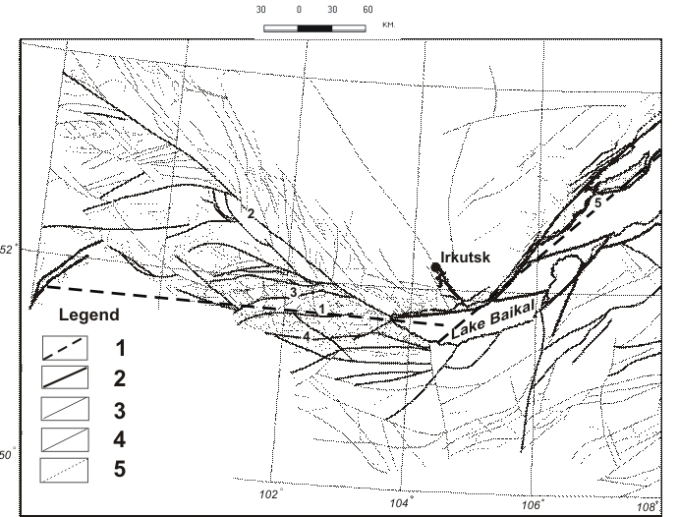

Figure 1. Scheme of recent active faults in the Pribaikalie, based on the proposed quantitative index of seismicity.
1 – zone of the recent fracturing in lithosphere with maximum values of the seismicity index (Tunka transform fault); 2 – most active faults, seismicity indices >1.0; 3 – active faults, seismicity indices 0.1-0.99; 4 – low active faults, seismicity indices ≤0.09; 5 – faults not considered in calculations.
Numbers: 1 – Tunka transform fault that coincides with the axis of the recent lithosphere destruction zone; 2 – Major Sayan fault; 3 – North Tunka fault; 4 – South Tunka fault; 5 – a fragment of the Obruchev normal fault.

Seismic events occur within areas of dynamic influence of seismically active faults; they display spatial and temporal oscillation migration of epicenters within the limits of the given areas. In seismically active zones, seismicity is determined by the behavior of a set of seismically active faults varying in ranks. Spatial and temporal regularities in reactivation of sets of faults in the zones of recent fracturing of the lithosphere are revealed from the quantitative and energy indices of seismicity of faults comprising the fracturing zones. Within the seismic zone, these regularities may give ways to reveal more complex regular characteristics of seismicity that can be applicable for predicting strong earthquakes.
The research was supported by the Russian Foundation for Basic Research (grant 04-05-64348).

References

- Imaev V.S., Imaeva L.P., Kozmin V.M. Active faults and seismotectonics of the north-eastern Yakutia. Yakutsk, Scientific Center, SB RAS, 1990. 148 p. (in Russian).
- Active fault map of the USSR and adjacent territories. 1:8,000,000 scale. Exp. notice / Edit. V.G.Trifonov. Moscow: GIN, 1987. 48 p. (in Russian).
- Fault map of the south of East Siberia. 1:1,500,000 scale. 1982. Edit. P.M.Khrenov. Mingeo SSSR, Leningrad, 1988 (in Russian).
- Levi K.G. Neotectonic crustal movements in seismically active zones of the lithosphere. Tectonophysical analysis. Novosibirsk; Nauka, SO. 1991. 166 p. (in Russian).
- Nesmeyanov S.A., Larina T.A., Latynina L.A et al. Identification and predication of hazardous tectonic rupture displacements in engineering prospecting for construction //Eng. Geology, 1992, 2. P.17-32 (in Russian).
- Nikonov А.А. Active faults: notion and problems of identification // Geoekologia, 1995, 4, p.16-27 (in Russian).
- Seminsky K.Zh. Tectonophysical regularities of the lithosphere destruction as exemplified by the Himalaya compression zone // The Pacific Ocean Geology, 2001, v.20, 6, p.17-30 (in Russian).
- Sobolev G.A. Fundamentals of earthquake prediction. Moscow: Nauka, 1993, 313 p. (in Russian).
- Sobolev G.A., Ponomarev A.V. Physics and forerunners of earthquakes. Moscow: Nauka, 2003, 270 p. (in Russian).
- Trifonov V.G. Regularities of active fault development // Geotectonics, 1985, 2, p.16-26 (in Russian).
- Sherman S.I. Destructive zones of the lithosphere, their state of stresses and seismicity // Neotectonics and recent geodynamics of continents and oceans. Moscow: RAS, MTK, 1996, p. 157-158 (in Russian).
- Sherman S.I., Bornyakov S.A., Buddo V.Yu. Areas of dynamic influence of faults (modeling results). Novosibirsk: Nauka, SB, the USSR Acad. Sci., 1983,110 p. (in Russian).
- Sherman S.I., Demianovich V.M., Lysak S.V. New data on the recent destruction of the lithosphere in the Baikal rift zone // Doklady Akademii Nauk, 2002, v. 387, No. 4, p. 533-536 (in Russian).
- Active Faults in and around Japan: the distribution and the degree of activity //J.Natur.Disas.Sci., 1980, v.2, No. 2, p. 61-99.
- Characteristics of active faults //Spec. Issue J. Struct. Geol., 1991, v/ 13, N 2. 240 p.
- Slemmons A.B. Paleoseismicity and fault segmentation // Proceed. 1st National Workshop on Paleoseismology. Rendiconti Soc.Geol. It., v.13. Roma, 1990, p. 5-8.
- Trifonov V.G. World map of active faults //Quarter. Internat.Spec. Issue. 1995, No. 25, p. 3-16.

