SUBDUCTION ZONE)

Anatoly Petukhin, Takao Kagawa
Geo-Research Institute, 4-3-2 Itachibori, Nishi, Osaka, 550-0012, Japan

Seismic attenuation is important for predictions of strong earthquake ground motions, and also it gives additional constraints on the physical properties of deep medium. In (Petukhin et al., 2003) the high-frequency (HF) Q-value, parameter of seismic attenuation was studied in Kinki region. In that work effect of geometrical spreading, which is necessary to remove before inversion for Q-value, was calculated numerically using realistic 3D velocity model and ray approximation. Studied area and slab location are shown in Figure 1. Figure 2 shows results for Q-value of Petukhin et al., 2003. Generally, estimated «total» Q-values agree well with results of other studies and with common expectations based on the tectonic structure, except of one striking result: Q-value for the lower crust become extremely low, Q_{total} ~ 20f ^{0.9}.
To interpret this result, in Figure 3 we compiled phenomena, related to attenuation, that were observed in studied region. They are: (1) seismogenic upper crust, depth 0-17km; (2) aseismic lower crust; (3) reflective lower crust (RLC) in depth range 17-35km revealed by the deep seismic exploration studies in studied region; (4) belt-like zone of the deep low-frequency tremor generation (LFT), parallel to the slab, which was observed using high-sensitivity borehole Hi-net stations; (5) a few deep low-frequency earthquakes, LFE (near Moho boundary) were observed in central part of Kinki region, far from volcanic centers; (6) in (Katsumata and Kamaya, 2003) generation of the LFT and LFE is explained by the presence of liquid phase in the crust near/above Moho boundary, which in turn can be explained by dehydration and/or partial melting in depth range 30-50km. Analysis of Figure 3 shows, that anomalously low Q-value in lower crust can be explained by two processes: (1) high intrinsic attenuation (low Q_{in} value) due to presence of fluids in the lower crust, which are indicated by the LFE and LFT phenomena; (2) high scattering attenuation (low Q_{sc} value) due to scattering on the lower crust heterogeneities, indicated by the RLC. To separate these two cases it is useful to analyze HF envelopes: in first case envelopes should have pulse-like shape with short duration and low coda, in second case envelopes should have intensive scattered part and long duration respectively.

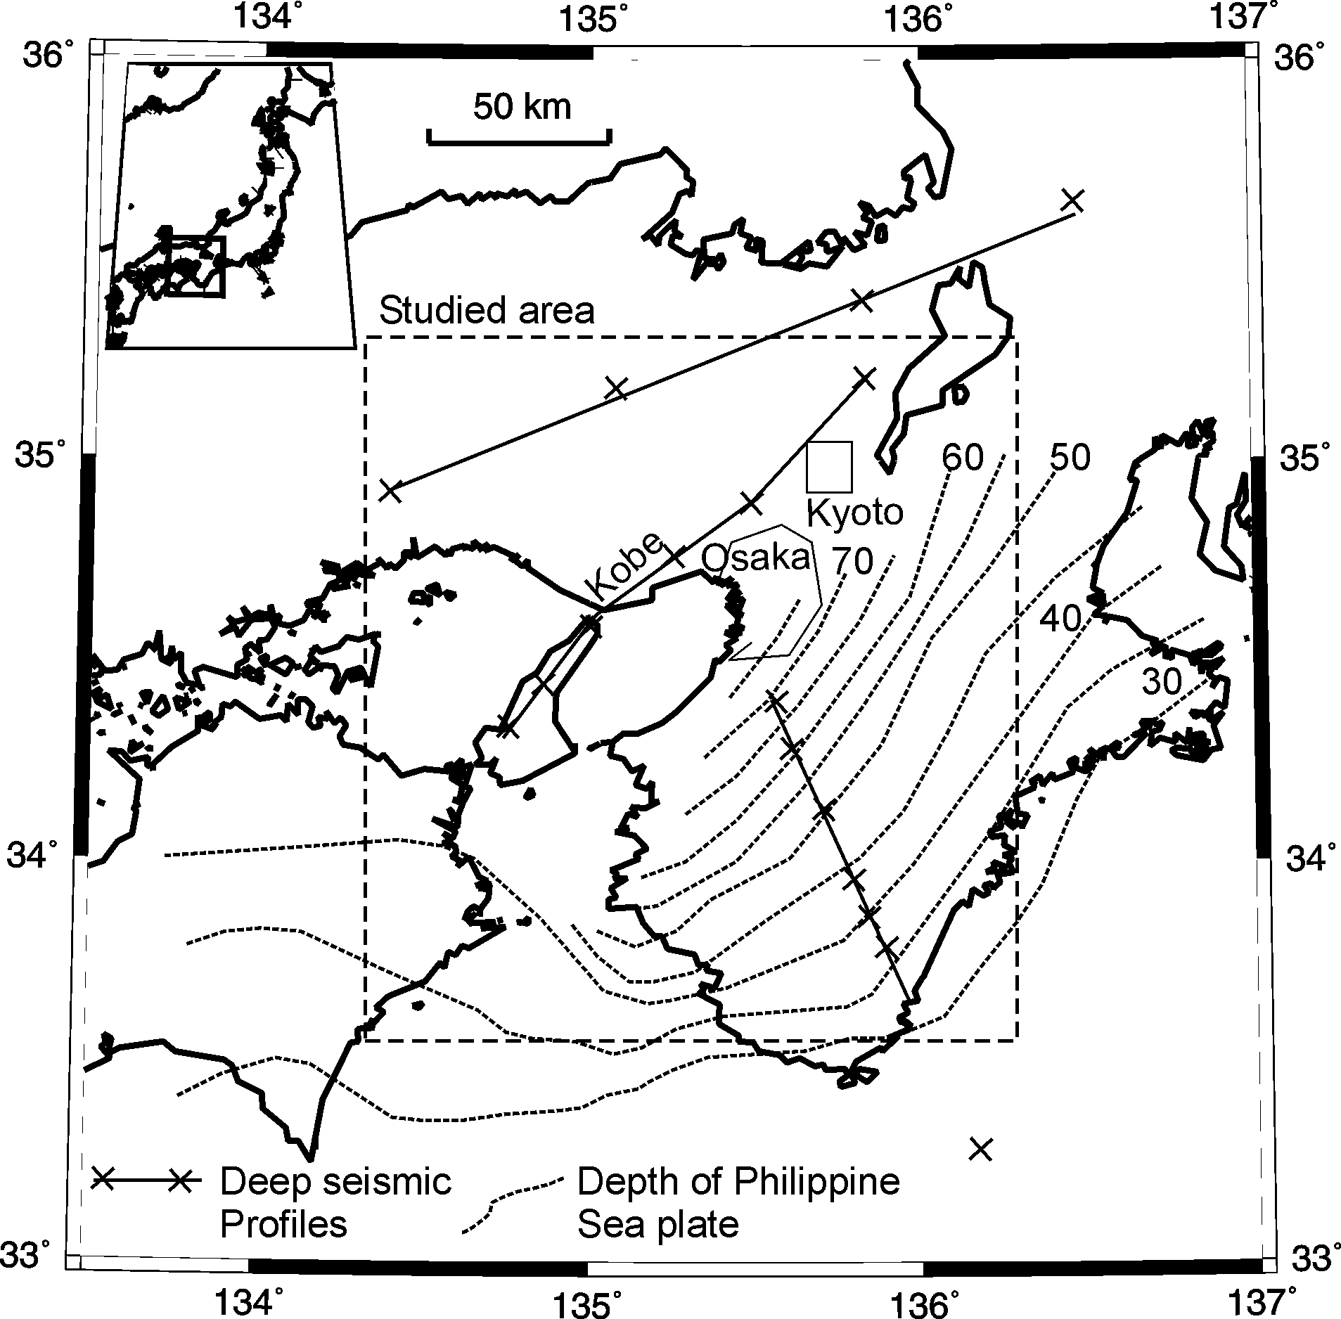

Figure 1. Map of the studied region.

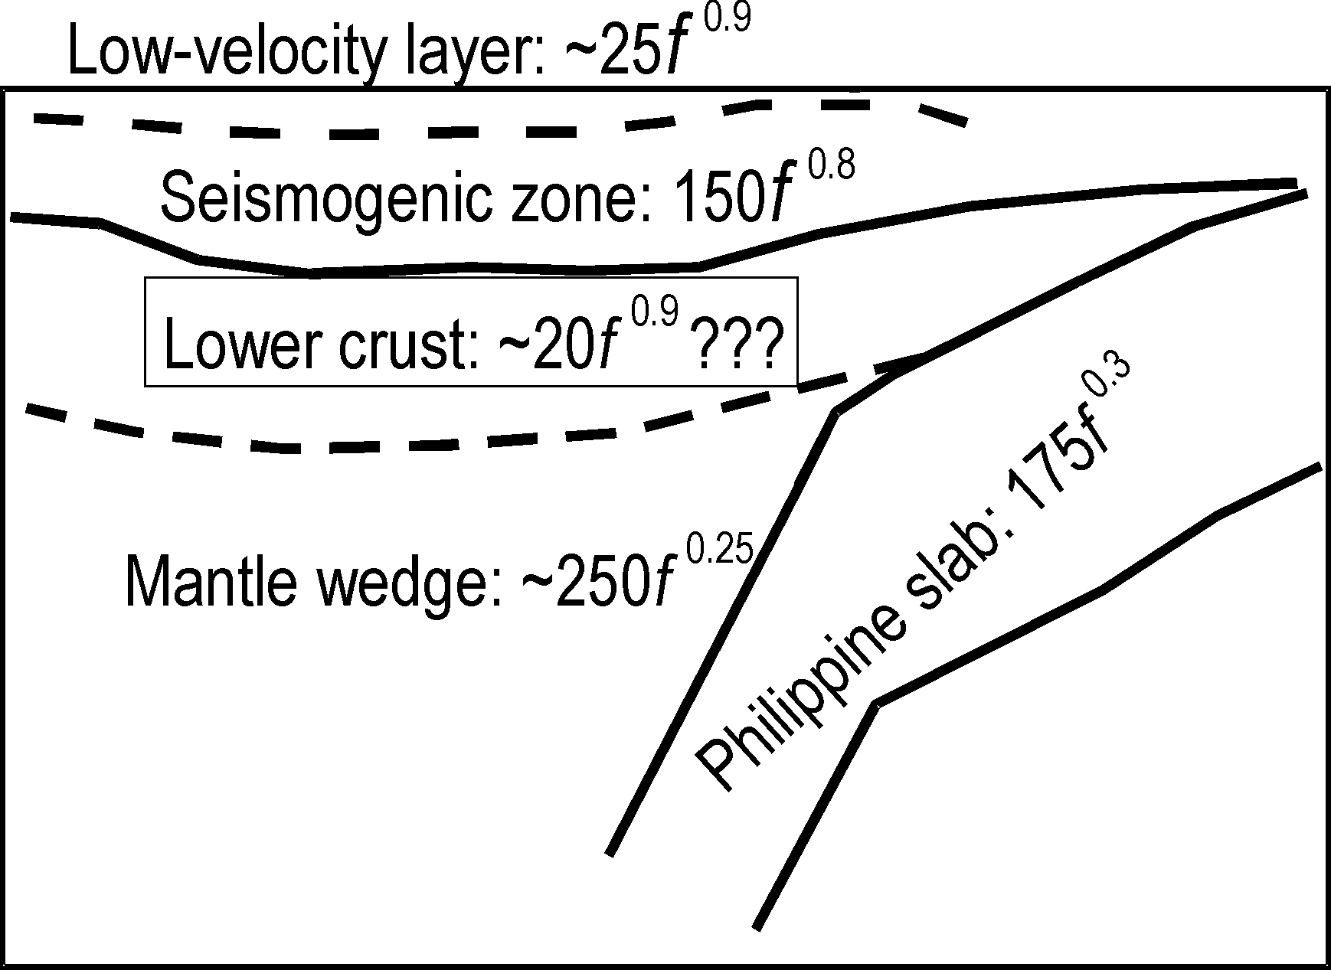

Figure 2. Results of inversion for Q-structure of Petukhin et al., 2003.

Envelopes for Kinki region were analyzed by Petukhin et al., 2004; Figure 4 shows the results. HF average envelopes of records of small earthquakes are shown for two cases: for shallow earthquakes with rays covering mostly upper crust and for deep earthquakes with rays covering upper and lower crust both. The results indicate that the first case of low Q_{in} value is valid for lower crust. To confirm this conclusion, in Figure 4 also shown envelope (dotted line) that was calculated from the envelope for upper crust but assuming low Q_{in} value, similar to the value of Q_{total} for lower crust. The result shows that assuming low value of Q_{in} it is possible to remove most of the difference between envelopes.
We conclude that Q_{total} value in lower crust could be low due to the partial melting or presence of fluids. Moreover, because the volume covered by rays in the lower crust is much larger than LFT and LFE zones, this phenomenon should be widely spread in the lower crust. We should mention that LFT is property of thin Philippine Sea plate subduction and was not observed in thick Pacific plate subduction zone (Obara, 2002). Based on all these results we propose a model of the HF seismic attenuation in Kinki Region (see Table below). In this model lower crust and mantle wedge are combined into one block to ensure significance of the model.
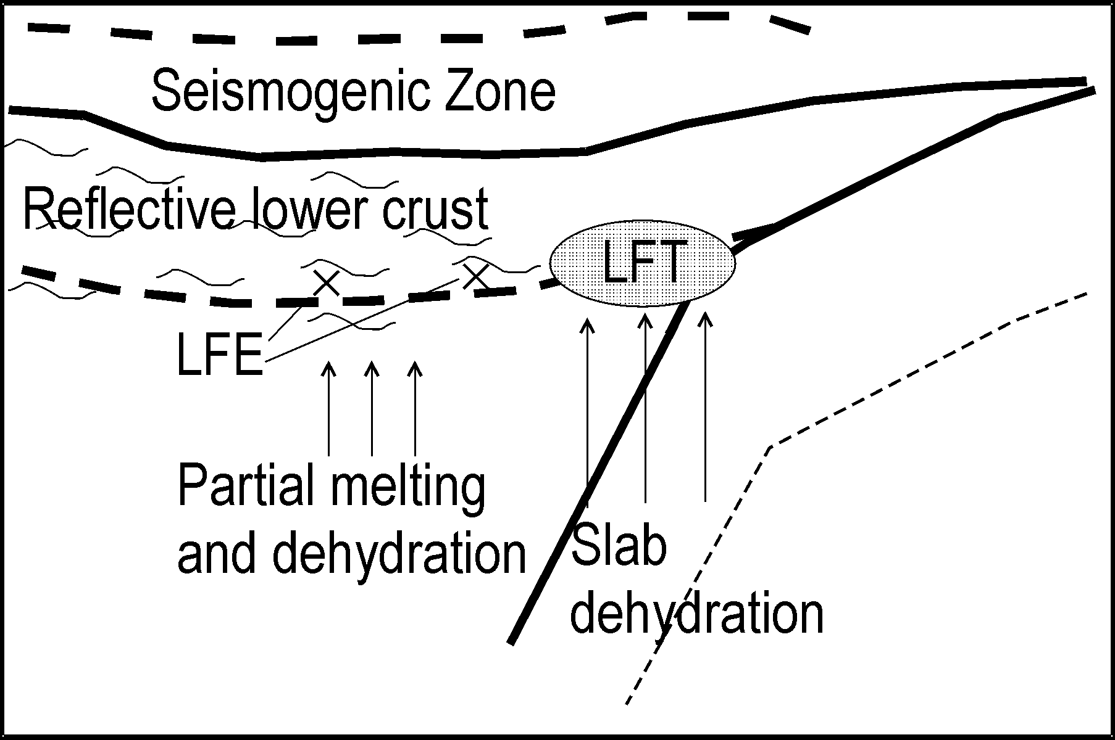 | 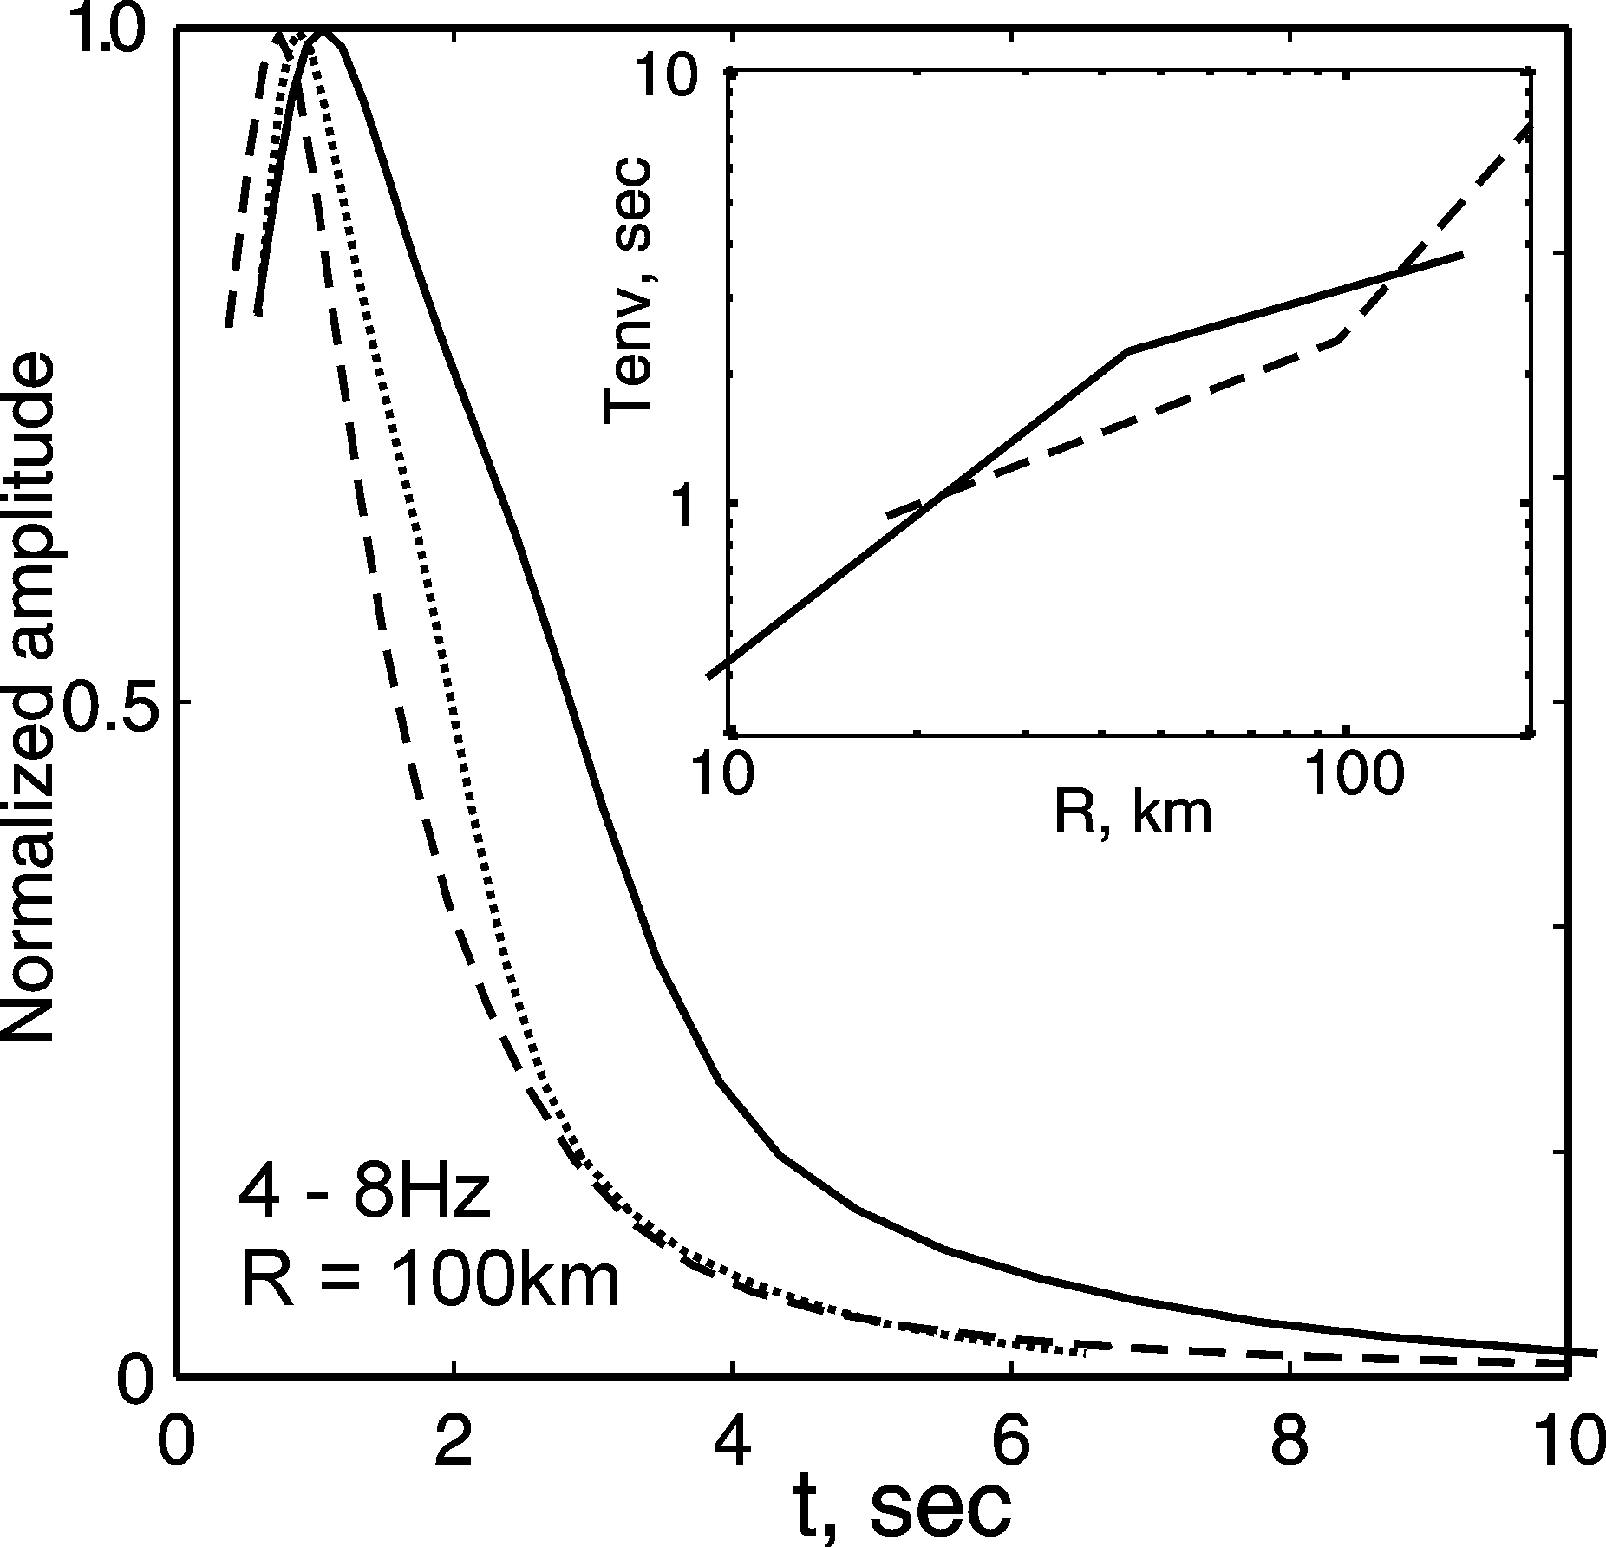
Figure 3. Compilation of observed or supposed phenomena, related to the attenuation. | Figure 4. Examples of average envelopes for Kinki region: upper crust (solid line) and lower crust (broken line). Inset shows dependence of duration vs. distance.

Q-value model for Kinki region.
Upper Crust | Lower Crust + Mantle Wedge | Philippine slab | Low-Velocity Layer
Q_{total} = 150f ^{0.8} Q_{sc} = 480f Q_{in} = 220f ^{0.7} | Q_{total} = 70f ^{0.6} Q_{sc} ~ 300f Q_{in} ~ 90f^{0.5} | Q_{total} ~ 175f ^{0.3} | Q_{total} ~25f ^{0.9}

References

- Katsumata A., N. Kamaya, 2003, Low-frequency continuous tremor around the Moho discontinuity away from volcanoes in the southwest Japan, Geophys.Res.Lett., 30, NO.1.
- Obara K., 2002, Nonvolcanic deep tremor associated with subduction in southwest Japan, Science, 296, 1679-1681.
- Petukhin A., K.Irikura, T.Kagawa, S.Ohmi, 2003, Estimation of Q-Value in Kinki Region, Japan, by Elimination of Elastic Attenuation Effect Using Ray Theory Approximation in 3-D Velocity Model. XXIII General Assembly of the International Union of Geodesy and Geophysics. Abstracts, SS04a/09P/D-040, B.503.
- Petukhin A., M.Tsurugi, T.Kagawa, and K.Irikura, 2004, Study of Average Envelopes of Small Earthquakes II: Systematic Analysis in the Area of the Tonankai - Nankai Earthquakes. 2004 Joint Meeting of Earth and Planetary Science, Chiba, Japan, S046-015.

