IN SITU EVALUATION OF VISCOELASTIC MODEL IN THE NEFTEGORSK EARTHQUAKE OF 1995 EPICENTER

S.M. Saprygin, V.N. Senachin

Scientific explanation in seismology and tectonics becomes mechanical. Thus a viscoelastic model defines mechanical state of rocks by tectonic deformations. It was suggested by V.A. Magnitsky as the differential sum of elastic and inelastic components. It is important to evaluate their relationship in specific situation.
Let us consider a system of right-lateral wrench faults of North Sakhalin (Fig. 1), which continue each other at a distance ∼ 200 km from the Neftegorsk earthquake epicenter (Upper-Piltun wrench fault) in Schmidt peninsula (Longriysk wrench fault). We shall believe that quantity of movement distinguished by earthquake or creep is transferred along this system and is accumulated as displacements on the Longriysk wrench fault, where it was determined by V.S. Rozhdestvensky.
Let l be the accumulated displacement (7 km). Then dl is the displacement, which is taken to the Neftegorsk earthquake epicenter for the characteristic time (700 years) and which is equal to 2 cm/year x 700 = 14 m (Fig. 2), dl_{y} is seismic displacement of the fault sides in the earthquake epicenter (4 m).
Let us write the model of viscoelastic body as dl = dl_{y} + dl_{h} or 14 m = 4 m + 10 m.
This model combined 13-second ripping of the Upper-Piltun fault and its 700-year preparation with the creep rate during which the fault was locked (Figs. 2, 3). As a result the anomaly in the field of stresses was formed. In the earthquake epicenter the unknown model was characterized by the relationship of displacements 4 m/ 14 m.

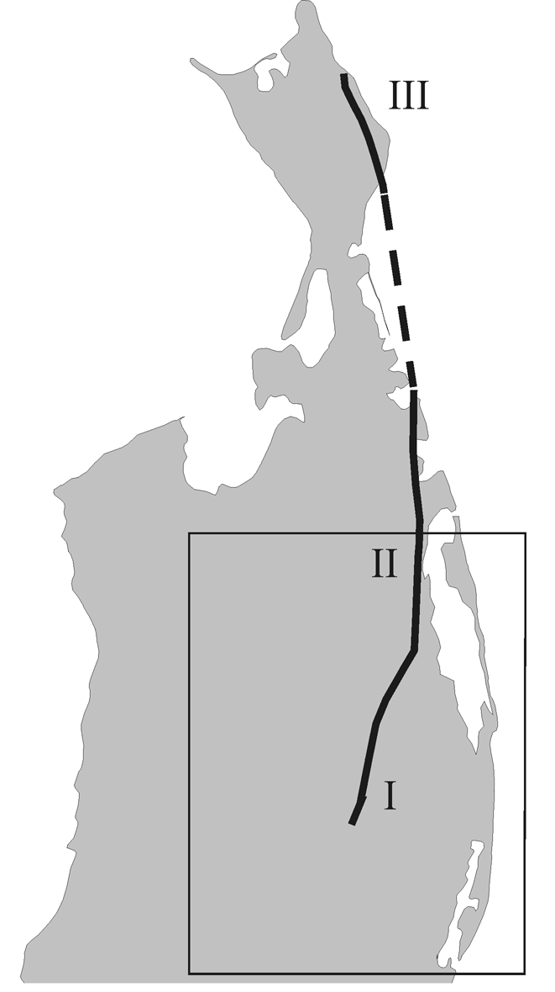

Fig.1. North Sakhalin wrench faults. 1 – Upper-Piltun, II – Ekhaby-Piltun, III – Longriysk.

Thus creeping is rather characteristic of Sakhalin interiors than seismicity. It is impossible to understand a mechanism of large earthquake preparation without instrumental observations of creeping.
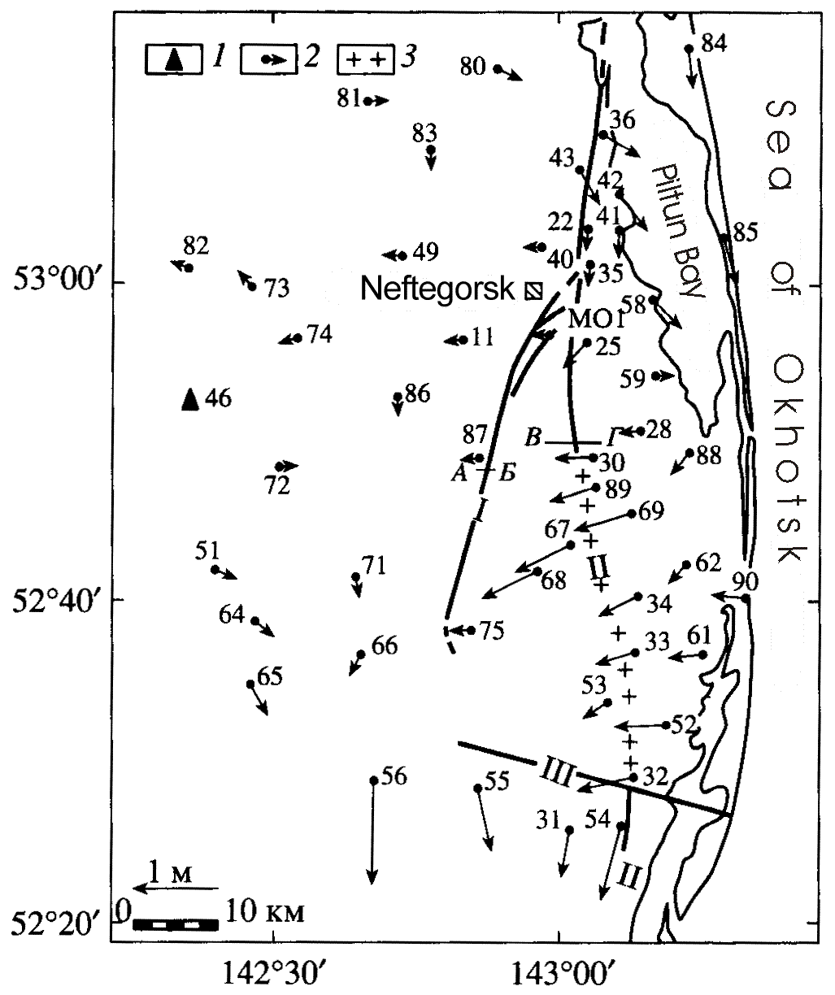

Fig.2. A scheme of horizontal movements of geodetic points in 1941-1970. 1 – fixed and 2 – mobile points; 3 – zone of diapers; 4 – faults: 1 – Upper-Piltun. II – Ekhaby-Piltun, III – Garomay. Sections: AB – Upper Piltun areas, VG – Paromay areas.

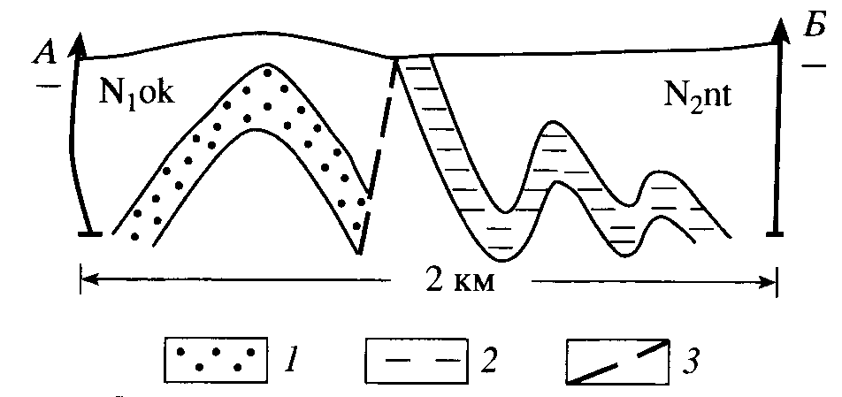
Fig.3. The geological section of the Upper Piltun area from drilling data. 1 – sandstones; 2 – clays; 3 – fault.

