VARIATIONS OF GEOACOUSTIC EMISSION LEVEL IN THE DEEP WELL AND THEIR CONNECTION WITH SEISMIC ACTIVITY IN THE SOUTH PART OF KAMCHATKA

V.A. Gavrilov, Yu.V. Morozova and A.V. Storcheus
Institute of Volcanology and Seismology FED RAS.
683006 Petropavlovsk-Kamchatsky, Russia. E-mail: vgavr@kcs.iks.ru

Continuous geoacoustic measurements have been acquired with a three-component geophone placed in a well more than 1000 m deep at Petropavlovsk-Kamchatsky starting in August, 2000. The geophone contains highly sensitive sensors consisting of magneto-elastic crystalline ferromagnets Amplitude-frequency characteristics of the geophone are 60 dB over a decade of change of frequency. The measured parameter is based upon the third derivative of ground offset. In addition to the geoacoustic measurements, continuous measurements of the electric component of the Earth's natural electromagnetic field were acquired in the same area starting in May, 2003 using a subsurface electric antenna. Geoacoustic and electromagnetic measurements were carried out in frequency bands with central frequencies 30, 160, 560 and 1200 Hz using an average, one-minute signal and automatically sent to the central station. The following is a summary of the results obtained during the last three years.
1. Periods of low seismic activity in the Kamchatkan subduction zone were characterized by a typical daily course of geoacoustic emission levels. Changes between minimum and maximum average emission levels could occur within 5-10 minutes. These changes corresponded to the time of sunset and sunrise in the area where measurements were carried out (Figure 1). Emission average level maximum values recalculated with the regard for ground displacement were about 25*10⁻¹² m and a minimum of 5*10⁻¹² m. The above-mentioned variations were most prominent on the vertical component channel of the geoacoustic signal with central frequencies of 30 Hz and 160 Hz. During the observation period in subduction zone of South Kamchatka earthquakes with M_{LH}>5.3 (Ks>12.5) (accompanied by the expressed daily course) did not happen. At the same time before all 23 earthquakes with M_{LH}>5.3 (Ks>12.5) occurred in the afore-named period considerable anomalies of geoacoustic emission level daily course (decreasing or disappearance of the daily course) were noted as far as 400 km from the observation point (Figure1).
The probability of this being an accidental coincidence is on the order of a value less than 10⁻⁵. In addition to the typical daily course disappearance, two close strong earthquakes (М_{LH}=6.2 and М_{LH}=5.9, epicentral distances 115 km and 160 km, respectively) were preceded by considerable coil-like anomalies in the geoacoustic noise level.

Figure1. 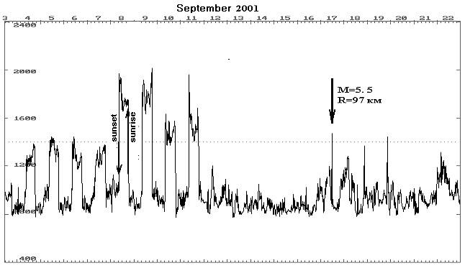 Example of geoacoustic emission level daily course anomalies before earthquakes. Vertical component, 160 Hz.

2. A comparison of the simultaneous geoacoustic and electromagnetic results from the well showed that geoacoustic emission typical daily course and the electromagnetic observations are connected with the presence of the D layer in the ionosphere. During periods of calm seismic conditions, geoacoustic and electromagnetic observations coincide well. The results indicate that the observations were most different during periods preceding quite strong earthquakes and relaxation periods.
3. The data obtained during the trial period led to the ability to forecast short-term earthquake in real time in Kamchatka starting in 2002. Between the 28th of March, 2002 and the 31st of May, 2003, nine earthquakes with М_{LH} > 5.0 occurring at epicentral distances up to 350 km from the measurement point were successfully forecasted. The ratio between the total time of observation and the alarm time was 2.2. In an area with epicentral distances more than 150 km one alarm was erroneous, however, no earthquake events were missed.

