ESTIMATION OF Q-VALUE IN KINKI REGION, JAPAN, BY ELIMINATION OF ELASTIC ATTENUATION EFFECT USING RAY THEORY APPROXIMATION IN 3-D VELOCITY MODEL

Anatoly Petukhin¹, Kojiro Irikura², Takao Kagawa¹, Shiro Ohmi²
¹Geo-Research Institute, Itachibori 4-3-2, Nishi-ku, Osaka 550-0012 JAPAN
²Disaster Prevention research Institute, Kyoto University, Gokasho, Uji, 611-001 JAPAN

We studied seismic waves attenuation in Kinki region, Japan, in high frequency range 1-10Hz. To do this it was assumed that observed amplitude Fourier spectrum is a product of source, S, elastic path attenuation, g, described by the Q-value inelastic path attenuation and site, G, effects:
$O=S⋅g⋅\text{exp}\left(−π\frac{\text{Rf}}{\text{vQ}(f)}\right)⋅G$, (1)
Frequently, to estimate path attenuation effect, Q-value is inverted under assumption that geometrical spreading is spherical (true for uniform velocity model). Actually, elastic attenuation g is complex effect that includes geometrical spreading in non-uniform velocity model, reflection and conversion on major velocity discontinuities, free-surface effect. In this study, elastic path attenuation was calculated using ray theory in 3-D velocity model. Source and site effects were eliminated using the double spectral ratio scheme (see also Figure 1):
$\text{DSR}=\frac{O_{\text{in}}⋅O_{\text{jm}}}{O_{\text{im}}⋅O_{\text{jn}}}=\frac{g_{\text{in}}⋅g_{\text{jm}}}{g_{\text{im}}⋅g_{\text{jn}}}⋅\text{exp}\left(−π\sum_{k}{\frac{R_{\text{in}}^{k}−R_{\text{im}}^{k}+R_{\text{jm}}^{k}−R_{\text{jn}}^{k}}{v}}⋅\frac{f}{Q^{k}}\right)$ (2)
Travel times inside blocks were calculated by the 3-D ray tracing. After this, Q-values in blocked media were inverted using a tomography approach.
For this study we developed 3-D velocity model for Kinki area (see Figure 2). This model includes: (1) low-velocity layer, (2) seismogenic zone (or upper crust), (3) lower crust, (4) subducted Philippine Sea plate, (5) mantle wedge (between crust and subducted plate) and (6) upper mantle (below subducted plate). It was assumed that velocities inside each layer have gradient of several percent, and that in high frequency range, at a point of crossing with velocity interface there is no reflection/conversion for upward rays. The whole media of the wave propagation were divided into blocks with constant Q-value according to the tectonic structure (see Figure 3): upper crust (UC), lower crust (LC), mantle wedge (MW) and subducted plate (SP). UC was subdivided into 6 smaller blocks with boundaries along main fault systems in Kinki region. For inversion we used borehole data of the Hi-net network, and hard rock data of CEORKA networks and so on. Totally, 1453 records were selected for inversion, number of used earthquakes - 128, stations - 91.

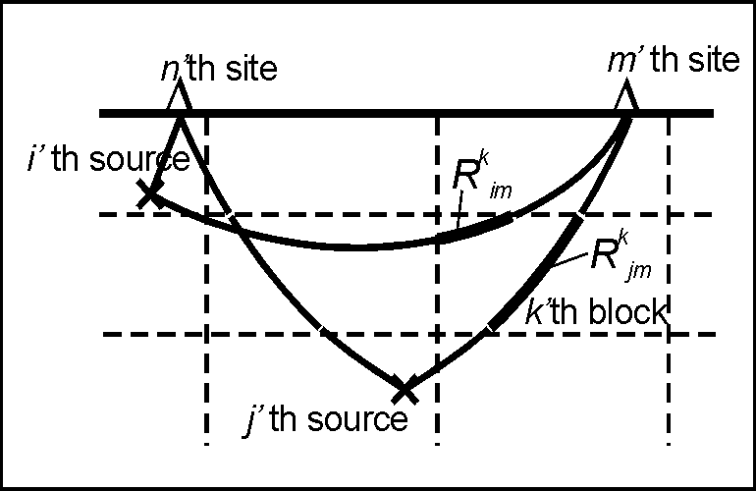

Figure 1. Scheme illustrating the modified double-spectral ratio tomography inversion procedure, see equation (2). Dashed lines – blocks, solid lines – rays, bold paths are the paths with constant Q = Q^{k}.
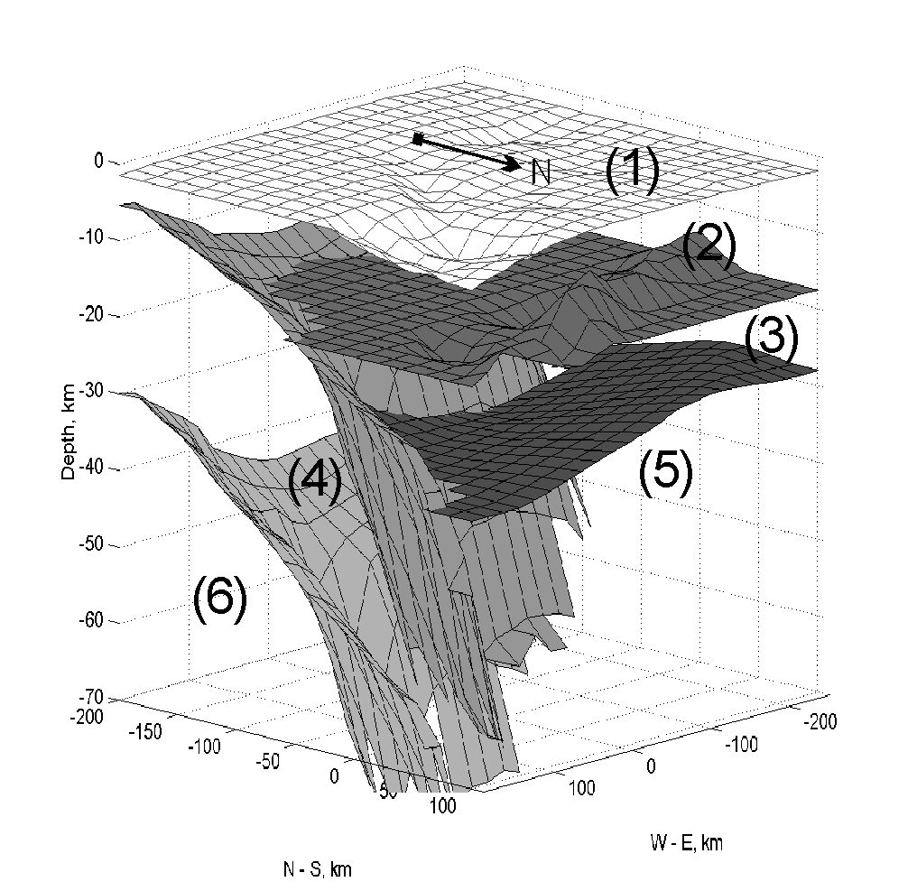
Figure 2. Bird’s-eye view of the velocity model used in this study.

Analysis of the results of inversion shows (see table below) that largest Q-value was in UC block, smallest was in LC+MW block. In UC, Q-value is larger in central Kinki region than in the southern or in northern parts of Kinki region. Although not stable enough, inversion with separated LC and MW blocks shows extremely low Q-value in LC that cannot be explained by the inversion instability only. To confirm validity of the elastic attenuation model, constrained in this inversion, we analyzed residues between observed and simulated values of the amplitude Fourier spectrum. Results show that except of highest frequency range the residues have no trend and their absolute value is smaller then residues of similar study of Petukhin et al., 2003, employing simplified 1-D velocity model.

Results of Q-value inversion.
 | Upper Crust |  |  | Lower Crust + Mantle Wedge | Philippine slab | Low-Velocity Layer
 | North of MTL | South of MTL | Northern Kinki | Lower Crust + Mantle Wedge | Philippine slab | Low-Velocity Layer
Q-value | 220f ^{0.86} | 120f ^{0.55} | 125f ^{0.68} | 70f ^{0.57}(LC+MW) ~20f ^{0.9}(LC) ~250f ^{0.25}(MW) | ~175f ^{0.3} | ~25f ^{0.9}

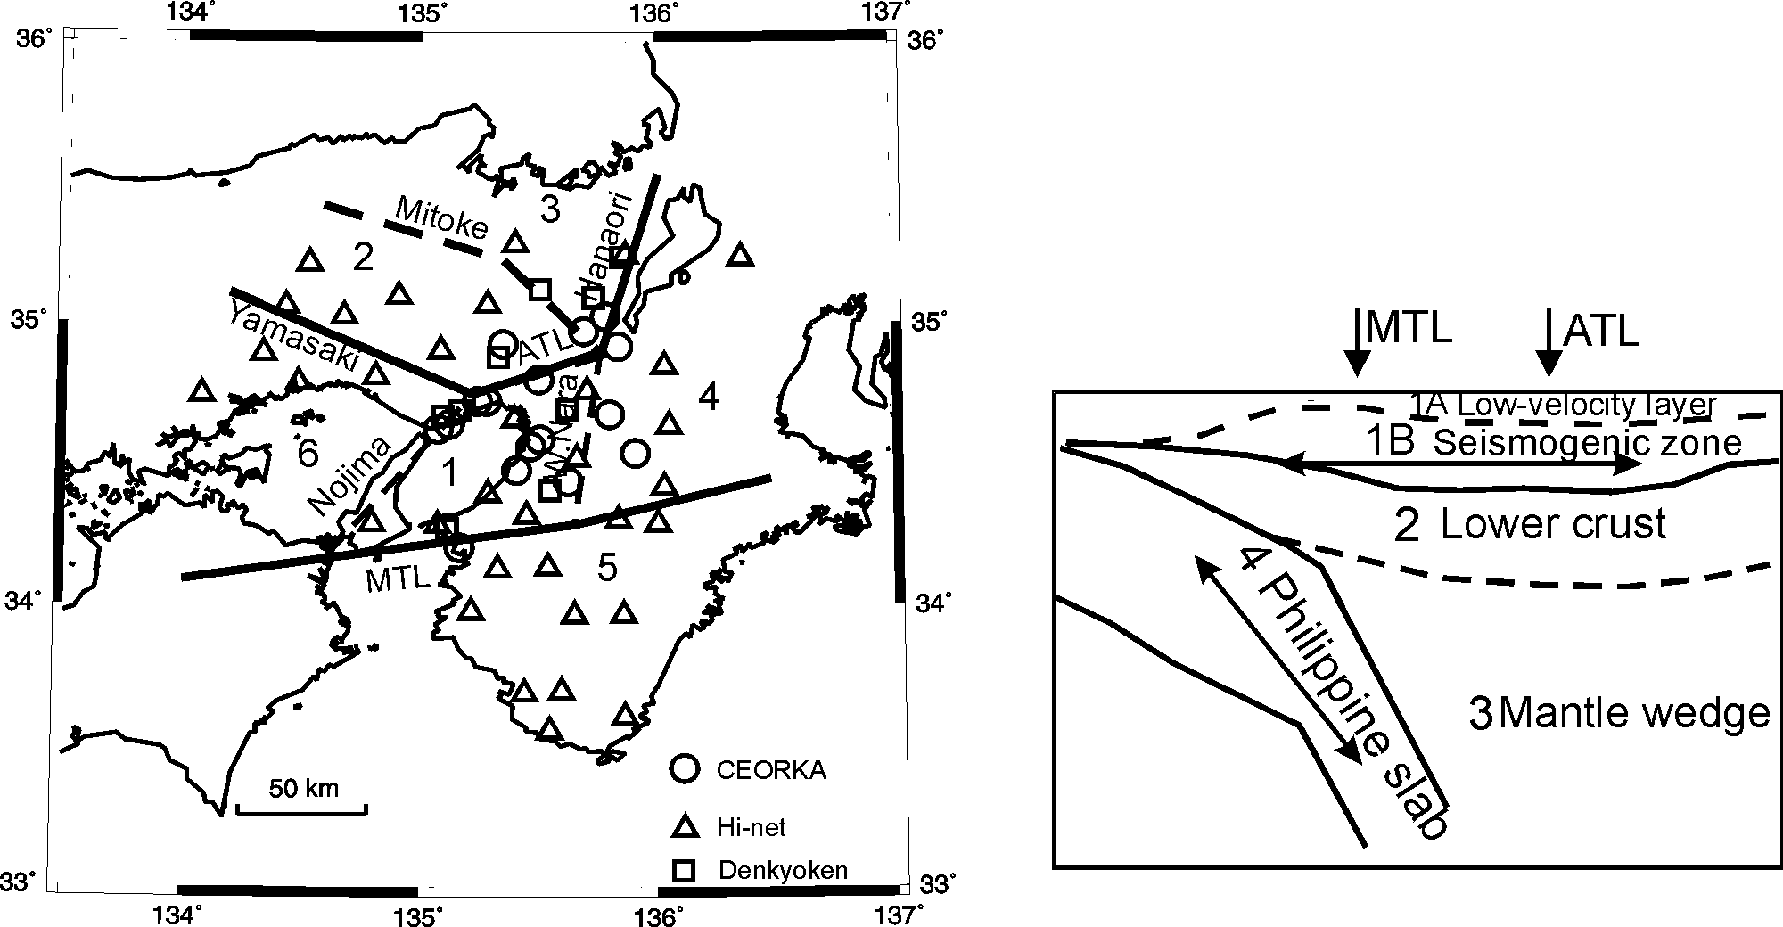

Figure 3. Assumed structure of tomography blocks. Left figure: block structure for upper crust. Right figure: block structure for lower part of the medium. Double arrows approximately indicate location ranges of the used earthquakes. On left figure, locations of observation sites used in the analysis are also shown.

Acknowledgements. Many thanks to National Institute of Earth Science and Disaster Prevention for providing the Hi-net data, the CEORKA research society and the Joint Research Program of the 11 electric power companies of Japan, for using their ground motion data.

Results of Q-value inversion.
 | Upper Crust |  |  | Lower Crust + Mantle Wedge | Philippine slab | Low-Velocity Layer
 | North of MTL | South of MTL | Northern Kinki | Lower Crust + Mantle Wedge | Philippine slab | Low-Velocity Layer
Q-value | 220f ^{0.86} | 120f ^{0.55} | 125f ^{0.68} | 70f ^{0.57}(LC+MW) ~20f ^{0.9}(LC) ~250f ^{0.25}(MW) | ~175f ^{0.3} | ~25f ^{0.9}

Reference

Petukhin A.G., K. Irikura, S. Ohmi, T. Kagawa, 2003, Estimation of Q-values in the Seismogenic and Aseismic Layers in the Kinki Region, Japan, by Elimination of Geometrical Spreading Effect Using Ray Approximation, Bull.Seism.Soc.Am., 93, No.4, 1498-1515.

