GEOMAGNETIC VARIATIONS CAUSED BY TIDAL ACTION

O.V. Sheremetyeva, A.N. Krolevets

Kamchatka State University of Education, Russia
1. Introduction. The Earth’s magnetic field is varying constantly. Sources of variations are situated in a fluid core, magnetosphere, ionosphere, lithosphere and on the Sun [1, 2, 4]. In the other article [2] it was shown, that seismic processes might serve as the cause of local geomagnetic variations. It means that the magnetic field measured depends on the processes of a planetary scale as well as on local ones. Up till now the relative contribution of each of them hasn’t been specified. Some of variations have signs of periodicities. Diurnal variations are well known and investigated. They are for example, solar-diurnal with 24 hour period and the lunar-diurnal with 25,8 hour period (wave O₁) [3]. It is considered [4], that the diurnal variations of the magnetic field have the sources in the upper stratums of the atmosphere - in the Heaviside layer of ionosphere. These sources are ring currents caused by the main geomagnetic field of the Earth in moving masses of conductive air at the height of about 100 kms above the surface of the Earth. The sources are remaining fixed between the Sun and the Earth. The entire current in a daylight circuit for solar-diurnal variations approximately equals to 62000 A (in an equinox) and 89000A (during a solstice), and for the lunar-diurnal accordingly equals to 5300 A and 11000 A. The nature of variations that have periods of lunar tidal waves is less investigated. In our opinion, planetary sources and ring current in the core of the Earth should respond to the tidal action. However the role of each source remains unclarified until direct estimates are made.
The aim of the given paper is the estimation of the geomagnetic variations owing to the tidal distortions of the ring currents that create geomagnetic field.
2. The nature of the tidal variations of the planetary geomagnetic field.
а) Distortions of ring current in the core. It is natural to guess, that the tidal distortions of this current circuit should lead to geomagnetic variations with the tidal frequencies. The magnetic field of the Earth is created by the current which flows in the core. Hereafter we shall assume, that the circuit of this current coincides with the magnetic equator of the core. The whole Earth and also its core, the boundary of the core are been distorted by tides. As a result of the distortion the current flows on a deformed loop. The disappearance of the current in an undistorted contour and its appearance in an distorted one is equivalent to the appearance of the quadrupole constituent of geomagnetic variations with the tidal frequencies in the planet scale. Let’s show it and carry out the relevant calculations.
Fig.1. Alteration of the ring current contour form as a result of diurnal tidal waves action (a view on the southern magnetic pole).

Direction of a vector of the magnetic moment in lunes

Undistorted contour

Distorted contour

dl
-I₀
I₀
Let's consider one of four segments made up by transversion of distorted with tidal action and undistorted contours (fig. 1). We shall parcel the contour into a set of elementary parts $d\vec{ℓ}$. The current in each part equals to I₀. The shift of the parts due to the tidal distortion of the whole contour is equivalent to the superposition of elementary contours, each with the current I₀ on the undistorted contour. The elementary contours should fill the segment entirely. The currents of the adjoining sides of the adjacent elementary contours cancel each other. Similarly the current of all elementary contours cancels the current in the undistorted contour. The aggregated magnetic moment of all elementary contours of four segments turns out to be a source of geomagnetic variations with the tidal frequencies.
The model discussed has allowed estimating values of variations of a magnetic flux density for a number of phases of tidal waves O₁ and M₂ at various latitudes. The calculated values of the amplitudes of variations equal to 100^{-th} of nT.
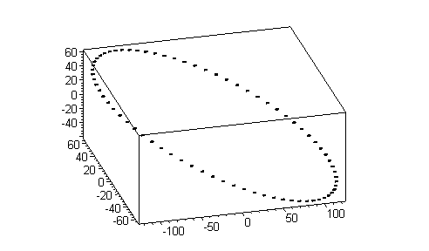
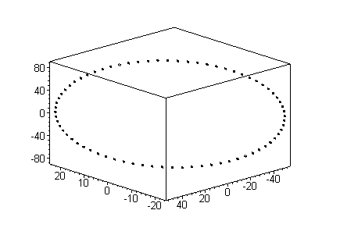
б) Distortions of ring current of the magnetosphere. Similar estimations were executed for the geomagnetic variations owing to the tidal distortions of ring currents, flowing in the magnetosphere at distances 2-7 radiuses of the Earth. These currents flow eastward at distances up to 5-6 radiuses of the Earth and the westward at larger distances [4]. For simplicity of calculations we shall consider undistorted currents to be circular and concentrated in an ecliptic plane. One of the currents flows at distance 5 radiuses, and another - 7 radiuses of the Earth. Their aggregate contribution was taken into account at evaluations of magnetic flux density variations. The calculated amplitude values of variations of magnetic flux density depends on tidal wave O₁, M₂ phases and equals to tens nT. The hodograph of a vector of variations of a magnetic flux density with the periods of waves М₂ and О₁ is an ellipse. If the source of geomagnetic variations is located in the core then the major semi-axes of the ellipses accordingly have the values (in nT) 107⋅10⁻⁶ and 80⋅10⁻⁶ for wave М₂ (Fig.2a), 204⋅10⁻⁶ and 76⋅10⁻⁶ (Fig. 2b) for wave О₁. The ellipses on fig. 2 are submitted in coordinate system where plane B_{x}B_{y} is parallel equatorial, and В_{х}В_{z} is parallel to a plane of a zero meridian.
B_{y⋅}10¹⁵, T

B_{z⋅}10¹⁵, T
a)
b)
0
π/2
π

3π/2

3π/2
0
π
π/2
Fig.2

B_{x⋅}10¹⁵, T

B_{z⋅}10¹⁵, T
B_{x⋅}10¹⁵, T

B_{y⋅}10¹⁵, T

Conclusions. The geomagnetic variations for Petropavlovsk - Kamchatsky which source is ring current in the core have values of about the 100-th nT. The variations which source is in the magnetosphere have values of about the tens nT. The hodograph of a vector of variations of a magnetic flux density is an ellipse. The plane of an ellipse is canted to an equatorial plane under corners accordingly 32° for wave O₁ and 91° for wave M2 for ring current in the core, and 71° for wave O₁ and 97° for wave M2 for ring current in the magnetosphere.

References

- Gokhberg M.B., Morgunov V.A., Pokhotelov O.A. Seismoelectromagnttic phenomena. M.: Nauka, 1988. 174 p.
- Sheremetyeva O.V., Krolevets A.N. The possible process of the magnetic variations. Vulcanol. Sesmol., 2004, # 4.
- Melchior P. The Earth Tides, Oxford, 1966. Translated under the title Zemnye prilivy, Moscow: Mir, 1968.
- Janovskii B.M. Terrestrial Magnetism. Leningrad: LGU, 1978. 592p.

