THE INTERNATIONAL WORKSHOP ON THE EXPLOSIVE VOLCANISM

(50TH ANNIVERSARY OF THE 1956 BEZYMIANNY ERUPTION)

Institute of Volcanology and Seismology FED RAS
Petropavlovsk-Kamchatsky, March 25-31, 2006

FIRST CIRCULAR

Objectives:

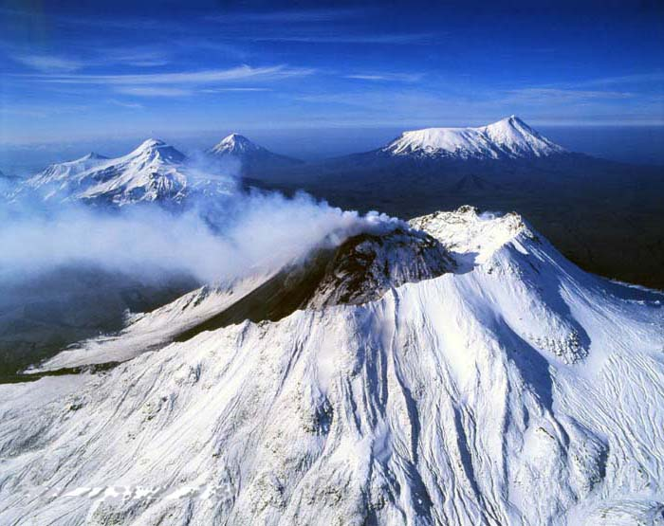
Explosive volcanism causes a variety of dangerous phenomena, such as pyroclastic and lava flows, surges, mud flows etc. Ash clouds may spread for hundreds or thousands of kilometers. More distant areas may be affected by such explosions due to the dispersion of ash particles and aerosols in the troposphere and lower stratosphere. This may affect the atmosphere of the entire Earth causing haziness, weather anomalies, and global temperature decrease. On March 30, 1956 a devastating blast destroyed the summit of Bezymianny volcano in Kamchatka forming 1.5-km-wide crater. The blast was instantly followed by a paroxysmal eruption, which sent an eruptive column to the altitude of more than 40 km. The volcano became 180 m lower in comparison with its height before the explosion. The total volume of the erupted material comprised nearly 2 km³. A city like Paris would have been covered with a 10-m-deep layer of pyroclastics, if it had been near the volcano. The workshop is dedicated to the 50th anniversary of the 1956 Bezymianny eruption. It will bring together scientists with various backgrounds from different countries. The meeting will serve as an excellent opportunity to discuss the nature of explosive volcanism as well as the most recent advances in mitigating volcanic hazards.
Bezymianny volcano (V. Gippenreiter)

Suggested topics for discussion:
· Directed blast explosions: Bezymianny and its analogues in the Earth history;
· Precursors of explosive eruptions and their applicability for forecasts;
· Explosive volcanism and its impact on environment on global and local scales;
· Remote sensing of explosive volcanism.

We anticipate that the results of the workshop will be published in a special volume of papers.

Steering committee:
Evgenii Gordeev and Boris Ivanov (IVS), Petropavlovsk-Kamchatsky, Russia
John Eichelberger, University of Alaska Fairbanks, USA.
Steve Sparks, Bristol University, Great Britain.

Local organizing committee:
Evgenii Gordeev (chairman), Yaroslav Muravyov (vice-chairman), Vladimir Leonov, Viktor Kazantsev, Olga Girina, Oxana Evdokimova, Elena Kalachova.

Format of the workshop:
The workshop will include review talks (30 minutes each), talks (20 minutes each), and poster presentations (2 or less posters for each participant). The organizing committee reserves the right to choose the form of presentation.
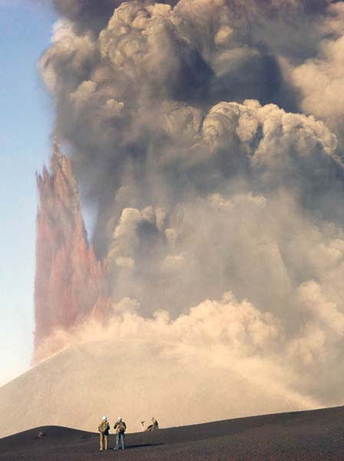
Meeting venue:
Institute of Volcanology and Seismology FED RAS, Petropavlovsk-Kamchatsky.

Excursions:
Bezymianny volcano, Karymsky volcano, New Tolbachik volcanoes.

Transportation:
Magadan Airlines offers weekly flights between Petropavlovsk-Kamchatsky and Anchorage. There are daily flights between Moscow and Petropavlovsk, as well as frequent flights from Khabarovsk, Vladivostok, and St. Petersburg.

Weather:
March in Petropavlovsk-Kamchatsky is generally sunny with temperatures +5-10°C.

Costs:
New Tolbachik volcanoes, 1975
(V. Gippenreiter)
We anticipate that costs for food and lodging will average about $100 per day. There will be a registration fee of about $250 per person to cover group events and transportation.

Accommodation:
Hotels “Edelweiss”, “Petropavlovsk”, “Avacha” and “Oktyabrskaya” are available. The least expensive room in “Edelweiss” is around $65 featuring basic services and facilities. The hotel is within an easy walking distance from the IVS.

Financial support:
We anticipate support from the Far East Division of the Russian Academy of Science (FED RAS), Administration of the Kamchatka Region, the US Geological Survey (USGS), National Science Foundation (NSF), University of Alaska Fairbanks (UAF), Geophysical Institute of UAF, and IAVCEI.

If you are interested in receiving further updates and circulars for this meeting, please send an e-mail to Oxana Evdokimova (evdokimova@kcs.iks.ru).

